9th/10th or 11th/12th Grades
Are you interested in STEM?
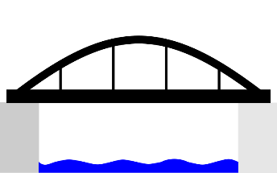
Are you interested in Bridge Building?
Then you should join:
Mrs. Pilon and Mrs. Massey at
Anchor Bay Middle School South for
Bridge Building Club (no fee or costs associated)
We will meet most Wednesdays from 3:00 pm to 5:00 pm in Mrs. Massey’s Room (601). We will meet from October 1, 2025 to February 2026.
Students will need to be in groups of only 3 to qualify as a complete team. 9th and 10th grade can be on a team and 11th and 12th can be on a team. Please talk with your friends and encourage them to sign up if you want to be on a team together.
Important Dates/Information:
- Meeting Dates: (October 1, 8, 15, 22 November 5, 12, December 3, 10, January 7, 14, 28 February 11, 25
Students may need to work on parts of this at home if they are not ready for the competition date in April.
- Design requirements for the Bridge and project portfolio requirements will be given at the first meeting
- Bridge Proposals will be evaluated by MDOT Engineers and Bridge Finalists will be announced in February
- The State Bridge Building Competition is tentatively scheduled for April this is a free trip and more information will be given out once we receive the official date.
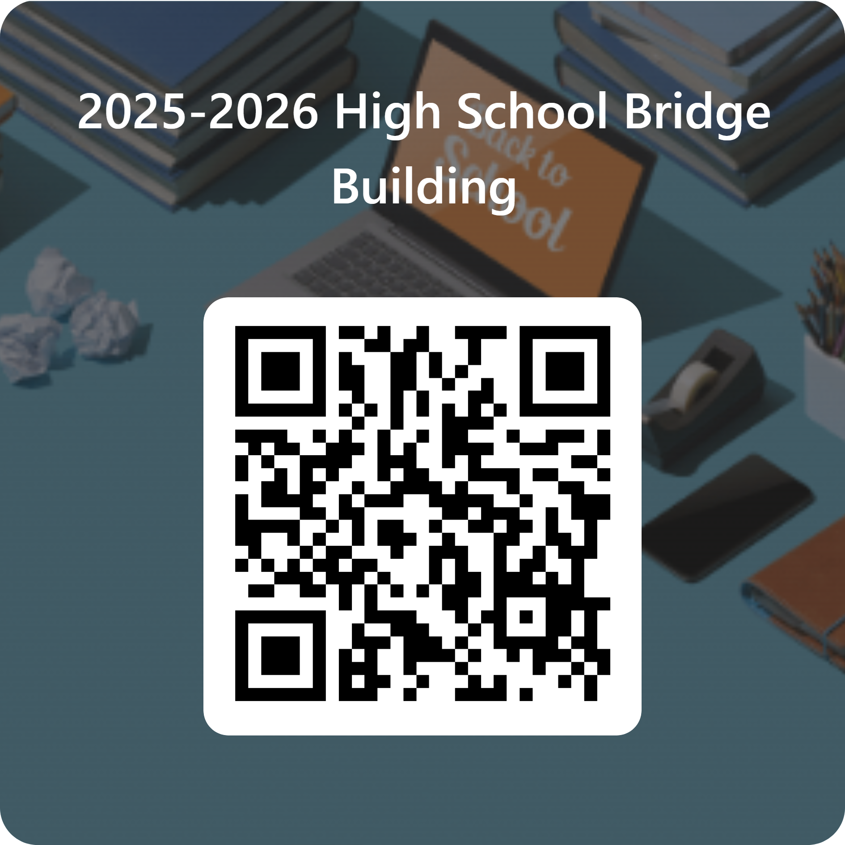
If you decide this if for you, then:
- Complete the sign up link:
- There will be a shuttle from the High School to South

